Project (2) [GEN211 Probability and Statistics]
Name \ Omar Ahmed Ramadan ID \ 240102684

Report on Quadratic Curve Fitting MATLAB Code
1. Introduction
The purpose of this code is to fit a quadratic curve to a set of 2D data points (x, y) using the Least Squares Method. After fitting, the code plots the original data and the estimated curve, and evaluates the fitting error.

2. Code Steps
.1 - Loading the Data
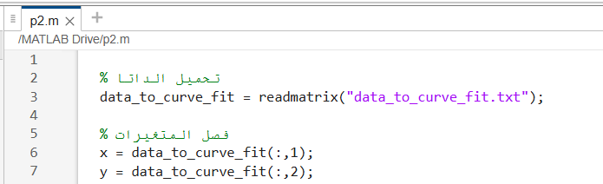
Reads a text file containing (x, y) data using readmatrix.
The first column is assigned to the independent variable x and the second column to the dependent variable y.

2 Plotting the Original Data
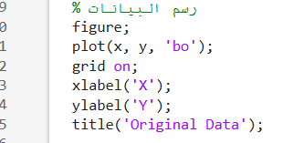
Plots the original data points as blue circles 'bo'.
Adds a grid for better visualization.
Labels the axes and sets a title.

3 Creating the Design Matrix
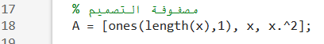
The design matrix is required for Least Squares fitting.
The first column: all ones (for the constant term c0).
The second column: values of x (for the linear term c1).
The third column: values of x^2 (for the quadratic term c2).

4 Computing the Curve Coefficients (Least Squares)
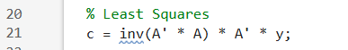
- The Least Squares solution calculates the coefficients using:
$$c=(A^{T}A)^{-1}A^{T}y$$
- c0 is the constant term, c1 is the linear term, and c2 is the quadratic term.

5 Displaying the Coefficients
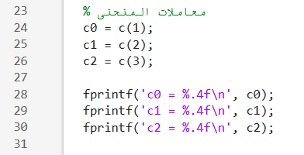
- Prints the numerical values of the coefficients rounded to four decimal places.

6 Calculating Predicted Values
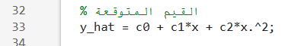
Uses the coefficients to compute the predicted values y_hat for each x.

7 Plotting the Fitted Curve
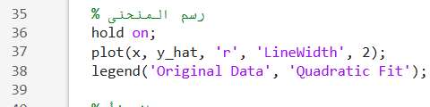
Plots the fitted quadratic curve in red 'r' with a thicker line (LineWidth = 2).
Adds a legend to distinguish the original data and the fitted curve.

8 Computing the Error (Residuals)
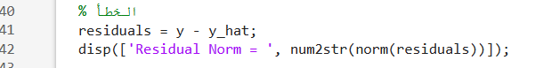
Computes the difference between actual and predicted values.
norm(residuals) gives the residual norm, indicating the overall fitting error. Smaller values represent better fit.
3. Outputs
- Plot of original data points.
- Plot of the fitted quadratic curve.
- Coefficients of the quadratic curve c0, c1, c2.
- Residual norm indicating the fitting error.

4. Analysis
- A small Residual Norm indicates that the quadratic curve fits the data well.
- The fitted curve can be used to predict future values within the data range.

